Software Requirement Specifications
< Decentralized Cybersecurity Log Management System >



Submitted by
<Khawaja Muhammad Tariq Raheem (01211)>

Submitted to
<Mr. Muzammil U Rehman>

Department of Information Technology
Faculty of Computing
The Islamia University of Bahawalpur

Meeting Details
Sr No | Details | Date | Supervisor Signature
Table Of Contents
1. Introduction 4
1.1. Purpose 4
1.2. Scope 4
1.3. Definitions 4
2. Overall Description 4
2.1. Product Perspective 4
2.2. Product Functions .……………………………………………………………………………………………………………..4
2.3. User Classes ……………………………………………………………………………………………………………………..…5
2.4. Constraints ………………………………………………………………………………………………………………………….5
2.5. Assumptions ……………………………………………………………………………………………………………………….5
3. System Features ……………………………………………………………………………………………………………………….5
3.1. Log Collection …………………………………………………………………………………………………………………….5
3.2. Decentralized Storage ………………………………………………………………………………………………………..5
3.3. Log Indexing & Query ………………………………………………………………………………………………………5
3.4. Analytics & Alerts …………………………………………………………………………………………………………..5
3.5. Access Control ………………………………………………………………………………………………………………..6
4. External Interfaces Requirements ……………………………………………………………………………………………6
4.1 User Iterfaces ………………………………………………………………………………………………………………….6
4.2 Hardware Interfaces ……………………………………………………………………………………………………….6
4.3 Software Interfaces …………………………………………………………………………………………………………6
4.4 Communicatio Interfaces ………………………………………………………………………………………………..6
5. System Requirements ………………………………………………………………………………………………………………...6
5.1 Functional Requirements ……………………………………………………………………………………………….6
5.2 Non-Functional Requirements ……………………………………………………………………………………….7
5.3 Security Requirements …………………………………………………………………………………………………..7
6. Other Requirements ……………………………………………………………………………………………………………….7
7. System Architecture Diagram ………………………………………………………………………………………………..8
8. References …………………………………………………………………………………………………………………………..….8

- Introduction
The Decentralized Cybersecurity Log Management System provides secure, tamper-proof, and scalable log storage using blockchain and distributed technologies. It ensures data integrity, auditability, and real-time threat monitoring.
  - Purpose
This SRS defines the functional and non-functional requirements of the Decentralized Cybersecurity Log Management System.
  - Scope
The system securely collects, stores, analyzes, and verifies cybersecurity logs using decentralized (blockchain-based or distributed) architecture.
  - Definitions
• Log: Recorded event generated by system components.
• Node: A participant in the decentralized network.
• Consensus: Mechanism to validate data across distributed nodes.
• Threat Intelligence: Analysis of security-related data to detect threats.
- Overall Description
  - Product Perspective
The system operates as a distributed logging platform using decentralized storage and verification.
  - Product Functions
• Collect logs from multiple endpoints
• Store logs in tamper‑resistant decentralized storage
• Verify integrity using cryptographic hashing
• Provide real‑time analytics and threat detection
• Support querying and auditing

2.3. User Classes
• System Administrators • Security Analysts
• Auditors • Network Engineers

2.4. Constraints
• Limited network bandwidth
• Storage redundancy requirements
• Blockchain transaction overhead
2.5. Assumptions
• All nodes have stable connectivity
• Users are authenticated
• Endpoints generate standard log formats
3. System Features
3.1. Log Collection
• Collect logs in real time
• Support Syslog, JSON, CSV, and Windows Event Logs
3.2. Decentralized Storage
• Distributed ledger ensures immutability
• Cryptographic hashing for tamper detection
3.3. Log Indexing & Query
• fast search algorithms
• advanced filtering
3.4. Analytics & Alerts
• anomaly detection
• automated alerting

3.5. Access Control
• role‑based authentication
• multi‑factor login
4. External Interface Requirements
4.1. User Interfaces
• Web dashboard
• Command‑line API
4.2. Hardware Interfaces
• Servers, clients, distributed nodes
4.3. Software Interfaces
• Operating systems: Windows, Linux
• Security tools: SIEM, IDS, IPS
• REST APIs
4.4. Communication Interfaces
• HTTPS
• Secure RPC
• Peer‑to‑peer protocol
5. System Requirements
5.1. Functional Requirements
FR1: System must collect logs from at least 100 endpoints.
FR2: System must store logs on decentralized nodes.
FR3: Logs must be hashed before storage.
FR4: System must support querying logs by timestamp, ID, and keywords.
FR5: Alerts must trigger on detection of suspicious activity.
FR6: Admin must manage nodes and permissions.

5.2. Non‑Functional Requirements
NFR1: System must process logs under 2 seconds latency.
NFR2: System must ensure 99.9% uptime.
NFR3: Encryption must meet AES‑256 standards.
NFR4: User interface must be accessible and responsive.
5.3. Security Requirements
SR1: All logs must be encrypted in transit and at rest.
SR2: Multi‑factor authentication required for all admin operations.
SR3: Blockchain‑based immutability must prevent log tampering.
SR4: Audit trails for all actions must be maintained.
6. Other Requirements
• Backup and recovery rules
• Legal and regulatory compliance (GDPR, ISO‑27001, etc.)
• System scalability to thousands of logs per second.

7. System Architecture Diagram
High-level architecture:
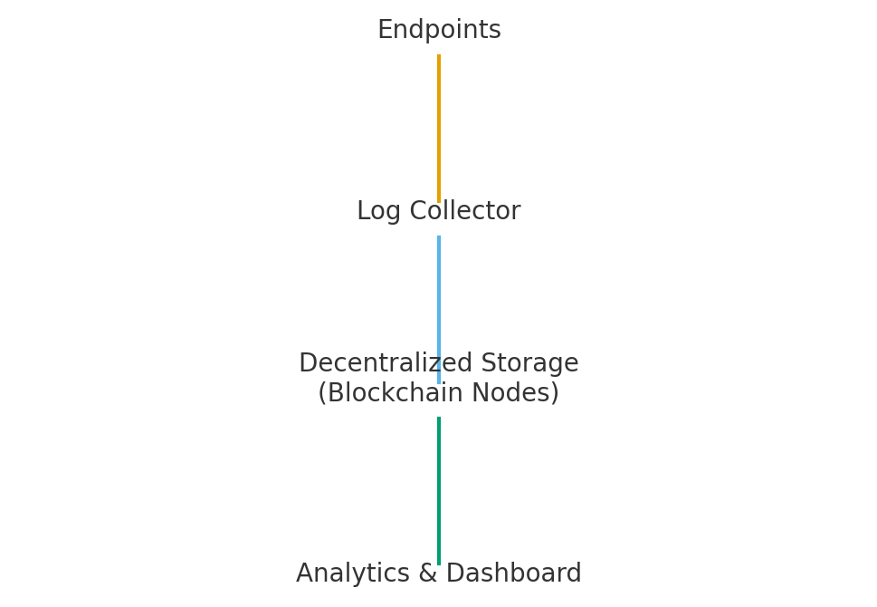

8.References
[1] ISO/IEC 27001: Information Security Management
[2] NIST SP 800-92: Guide to Computer Security Log Management
[3] Blockchain Security Architecture Standards
[4] OWASP Logging & Monitoring Guidelines

